How To Change Pitch in Audacity in few Simple Steps

For a free piece of software, one of the remarkable things about Audacity is how powerful it is. There are a host of powerful features that allow producers to work their magic on any kind of sound.
The range of effects in Audacity for sound editing, and the quality of those effects, will often easily match those of more expensive commercially-available rivals, and Audacity is a great example of how good free software can sometimes be.
In this article, we will be exploring one of Audacity’s tools and looking at how to change the pitch of a sound.

What Is Pitch?
Pitch is how high or low something sounds, to put it in the simplest possible terms. Something with a low pitch will have a lot of bass, and something with a high pitch will have a lot of trebles.
This is true for both voice and instruments used in music. A cello has a low pitch, a violin has a high pitch. A bass or baritone voice will have a low pitch, a soprano will have a high pitch.
By adjusting the pitch of something, we change the characteristics of the sound. For example, someone on a podcast may want to have the pitch of their voice lowered so they sound like they have more gravitas.
Or they may want to have the pitch raised so that the voice has a brighter, clearer sound. By changing the pitch, we change the way the sound is perceived.

How to Change Pitch in Audacity: Sound Editing
In order to change pitch in Audacity, we are going to use the Change Pitch setting. This lets you change the pitch with just a few clicks and makes adjusting the parameters simple.

Step 1.
Launch Audacity, then go to File, Open, then search your computer and select the track you want to work on.
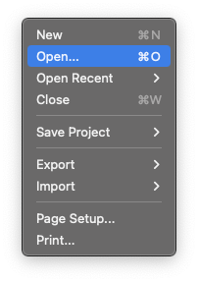
KEYBOARD SHORTCUT: CTRL+O (Windows), COMMAND+O (Mac) to bring up the File dialogue box.

Step 2.
Once the file is open, either select the whole track or select the part of the track you want to work on. The entire song or track will change color.
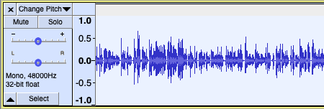
KEYBOARD SHORTCUT: CTRL+A (Windows), COMMAND+A (Mac) to select the whole track.
To edit part of the audio, left-click your mouse then drag it so that the part of the audio file you want to work on is selected. The highlighted part of the song will change color and the changes will only be applied to that part of the audio.
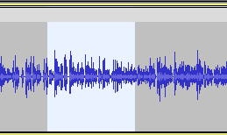

Step 3.
Go to the Effect menu and select Change Pitch.
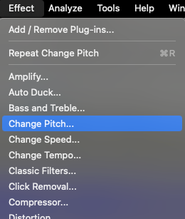
This will open the Change Pitch dialogue box.
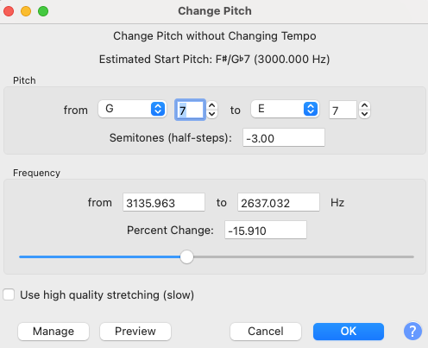

Step 4.
The settings for the Change Pitch tool are as follows:
- The Pitch From and To Fields: This lets you adjust the pitch by a musical note. In the example above, the effect is changing pitch from a G to an E, so the audio has a lower pitch.
- Semitone: This allows you to edit the pitch by semitones. A full octave is eight tones in music, but if you want to adjust the pitch by an octave you will choose a value of 12. On a piano that would be the eight white keys and five black ones, or 13 notes, and the gaps between the thirteen notes (the semitones) equal 12.
- The Frequency From and To Fields: Measured in Hertz (Hz), this allows you to adjust the pitch by a specific frequency rather than a note. Middle C in music, for example, is 256 Hz. The From Field is the lower frequencies, and the To Field is the higher frequencies.
- Percent Change: The amount you alter the pitch expressed in a percentage. You can also drag the slider to adjust the pitch or to measure the changes made by adjusting the other settings.
- Use High-Quality Stretching (slow): When this checkbox is selected, Audacity will process the change in pitch but at a much higher quality and with fewer distortions or audible changes on the resulting audio. The process will, however, take noticeably longer to do. This is covered in more detail below.
Every setting will reflect the changes made in another. So for example, if you adjust the frequency setting, the percentage setting will automatically update to let you know how much you have changed things, and the musical note setting and slider will change to match as well.
All changes will always be reflected in all of the settings.
In addition, there are the buttons across the bottom of the box:
- Manage: Gives access to a sub-menu that allows you to save your changes as a preset or load other presets into Audacity.
- Preview: This allows you to listen to your changes without committing to them.
- Cancel: Discards the changes you have made to the audio without affecting the track.
- OK: Applies the changes you have made.
- Question Mark: Takes you to Audacity’s help page.

Step 5.
Adjust whichever setting you want until you are satisfied with the end result, then press OK to apply the change to your track. The change will be applied to either the whole track or part of it, depending on what was selected.

Step 6.
Once you are satisfied with the changes you have made, save your audio file. Go to the File drop-down menu, select the Export option, then choose the file type you require.
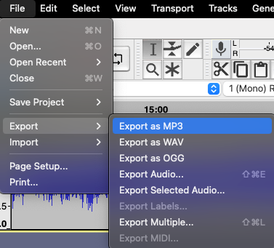
If you are working on a project, you might have multiple tracks in use. For example, a different track for each host on a podcast rather than everyone being on the same track. In this case, you may want to save your work as an Audacity project.
This means that the separate tracks will be preserved so you can return to work on them later. This is different from Exporting, which will merge all tracks together to create a single audio file. However, Audacity projects can only be opened by the Audacity software itself.
To save as an Audacity Project, go to File, then Save Project.
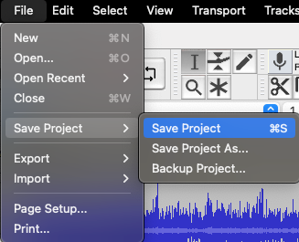
KEYBOARD SHORTCUT: CTRL+S (Windows), COMMAND+S (Mac)
And that’s how you change pitch in Audacity!
Did you like that? If yes, we also recommend you to check out another article, this time it would be about Pitch Correction in GarageBand. Enjoy!

Conclusion
Whether dealing with an instrument or a voice, Audacity makes it simple to change the pitch of your audio to whatever it is you are looking for.
The tool itself is easy to use and spending a little time adjusting the settings will help any budding producer get a feel for the kind of changes that can be made.

FAQ

How To Change Pitch in Audacity Without Changing Speed
In Audacity, this can be achieved by selecting the Use High-Quality Stretching (slow) option mentioned above.
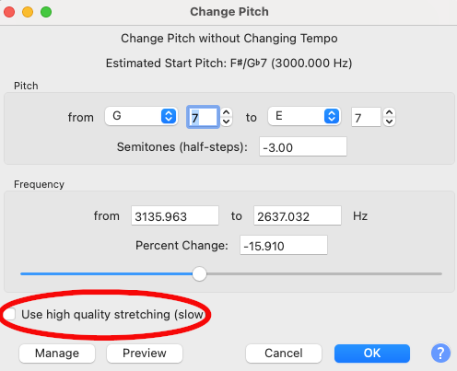
When this box is checked, Audacity will process the changes to your track precisely. However, this also takes significantly more processing power. Depending on how powerful your computer is, this could noticeably alter how long it takes Audacity to apply the effect to your track. This is why it has the word “slow” after it.

Does Changing the Pitch Change the Speed of the Track?
If you alter the pitch without using the High-Quality Stretching (slow) option, yes, this will change speed. The amount of change will depend on the parameters you adjust — the more effect that is applied, the more evident the change will be. Audacity doesn’t keep your track the same length by default.
This kind of pitch change is what’s known as a “time-stretching” effect. Normally to get something to sound lower you would slow it down. Imagine a 45rpm single being played on a record player at 33rpm. It will sound slower, but also lower. The reverse is also true as well — if you speed something up it will sound higher.
Using software to achieve this kind of pitch change keeps the track approximately the same length but lowers or raises the pitch without having to slow anything down or speed it up.
This can be imprecise, though, which is why the length of the track can vary. The high-quality stretching option above resolves this.

Does Changing the Pitch Also Change the Tempo?
No. If you have a piece of audio that has the pitch changed it does not change the tempo. If, for example, you had a piece of music in 4/4 time, it would still be in 4/4 times after a change in pitch.
The length of the track may vary, but the tempo does not. When you play the audio back it will be in the same tempo.

